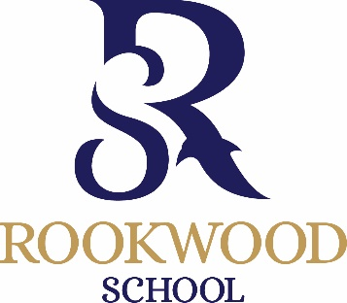
16+ Practical Scholarship Application - September 2023
To be completed by parents of external applicants (not currently at Rookwood) wishing to be considered for a practical scholarship and returned to admissions@rookwoodschool.org or delivered to the school office by Friday 13th January 2023. Current Rookwood students will automatically be considered for practical scholarships and all students will automatically be considered for academic scholarships.

Child’s name ………………………………………………………………………...
D.O.B. ……………………………………………
Address ...........................................................................................................................................................................……………………………………………………………………………………………………………………………………………………………….…………

Telephone No …………………………………………………………………… (Home)
…………………………………………………………………… (Mobile)
Present School: ……………………………………………………………………

I am interested in my son / daughter entering for the following scholarship(s), maximum of 2 practical subjects (marked *)
Please tick

Academic

Sports *

Art *
Please list instruments and grade:
Instrument | Grade

Drama *

Music *

Signed: …………………………………………………….
Please print name: ……………………………………………………

