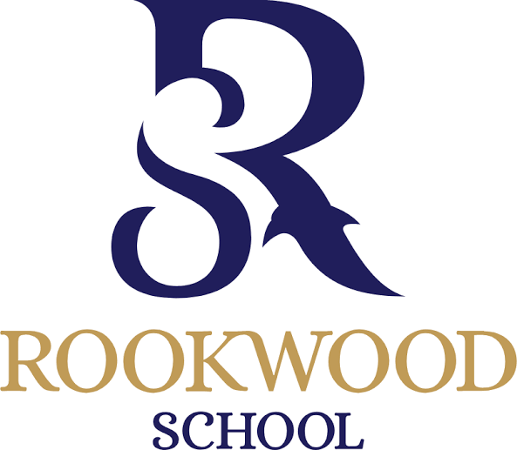

Rookwood School GCSE Results 2026
Number of Entries: 252
Grade 9 | 5%
Grade 8 | 8%
Grade 7 | 13%
Grade 6 | 25%
Grade 5 | 17%
Grade 4 | 16%
Grade 3 | 8%
Grade 2 | 5%
Grade 1 | 1%
U | 1%

