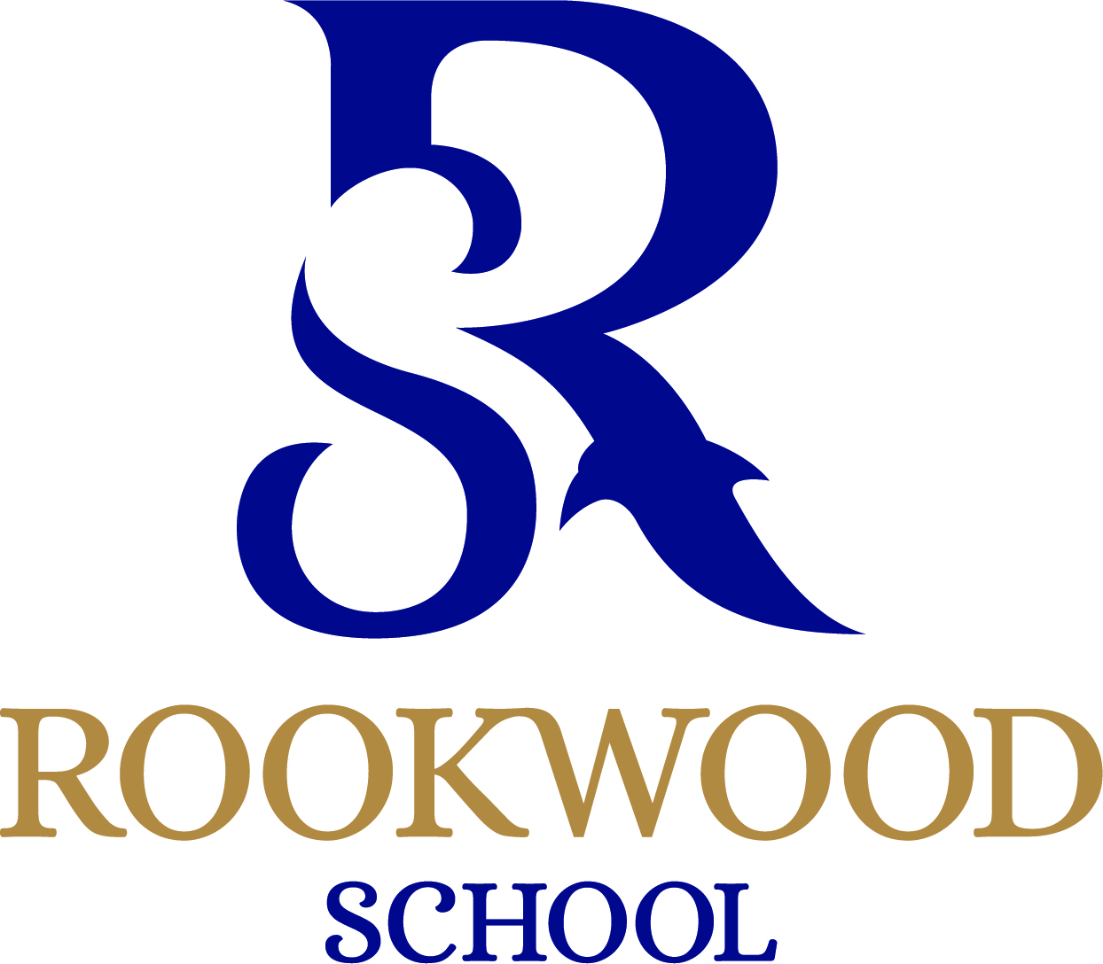

Residential Assistant House Parent, Andover, Hampshire

Closing Date: TBC

Interview Date: March 2023

Contract type: 43.5 hours per week

Contract term: Permanent/Term Time only

Salary: £12,000 to £18,500 dependent on experience and qualifications

Rookwood School is a successful non-selective co-educational Independent school for children from age 2 to 18.
Are you an enthusiastic and caring individual, seeking an exciting challenge to work within a dynamic team at one of Hampshire’s independent boarding schools?

Rookwood School, a forward thinking, imaginative and progressive school, seeks to recruit an Assistant House Parent to join our Boarding team. You may already be working in a similar environment or looking for new challenges. This post will suit someone with a willingness and ability to contribute to the wider life of the School e.g. offering clubs, activities, sports coaching etc. The post may suit a graduate thinking of a career in teaching and/or a responsible and mature 18/19 year old seeking their first career challenge on leaving education.

Working as part of the Residential Staff, you will work across the two Boarding Houses and in the wider school community (the specific area to reflect your own personal interests). You must be caring, enthusiastic, with a zest for life and a commitment to work as part of a team. In return, we offer a fun and enriching environment in which to work and live, single accommodation and meals during term-time, as well as the opportunity to understand the commitment required to work in an independent school.

We have two small boarding houses, girls and boys, home up to 25 boarders aged 8-16, with a shared garden, kitchen and common rooms. The children live within a unique family setting and enjoy a home-from-home setting. The Assistant House Parent will play a key role in their pastoral care, within the Boarding House team ensuring the Boarders time at the school is enjoyable, safe, caring and stimulating.

Previous boarding experience is desirable but not essential, as these are assistant/support roles.

Salary £12,000 – £18,500 experience and qualifications dependent, up to and average of 43.5 hours per week including weekend rotas.

Holding a driving licence is essential and a willingness to drive a minibus (training provided).

In return, we offer you:
- A competitive salary based on skills and experience
- 4 weeks paid holiday entitlement
- A professional, hardworking and supportive team of staff
- Opportunities for further professional development
- Employee assistance provision
- Access to reduced educational fees for qualifying children
- Free hot/cold lunch when on duty
- A caring and supportive working environment within a vibrant and successful school community

Applications are to be sent online or posted to: HR Department, Rookwood School, Weyhill Road, Andover, SP10 3AL.
The advert may close prior to the stated date and interviews will take place as soon as a suitable field of candidates is obtained therefore early submission of applications is recommended.
This school is committed to safeguarding and promoting the welfare of children and young people and expects all staff to share this commitment. An enhanced DBS check is required for this role.

