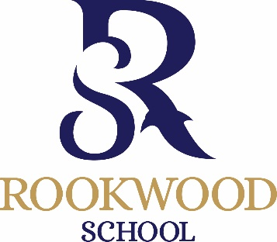

16+ Practical Scholarship Application
September 2022
To be completed by parents of external applicants (not currently at Rookwood) wishing to be considered for a practical scholarship and returned to admissions@rookwoodschool.org or delivered to the school office by Monday 10th January 2022. Current Rookwood students will automatically be considered for practical scholarships and all students will automatically be considered for academic scholarships.

Child’s name ………………………………………………………………………... D.O.B. ……………………………………………
Address ........................................................................................................................................................................
……………………………………………………………………………………………………………………………………………………………….
……………………………………………………………………………………………………………………………………………………………….

Telephone No …………………………………………………………………… (Home)
…………………………………………………………………… (Mobile)
Present School: ……………………………………………………………………

I am interested in my son / daughter entering for the following scholarship(s) maximum of 2 practical subjects
Please tick

Sports

Art
Please list instruments and grade:
Instrument | Grade

Drama

Music

Signed ……………………………………………………. Please print name ……………………………………………………

