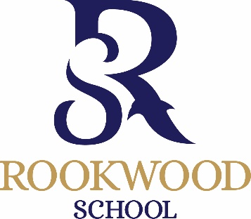
13+ Scholarship Application
September 2022
To be completed by parents of internal (current Rookwood pupils) and external applicants and returned to admissions@rookwoodschool.org or delivered to the school office by Monday 10th January 2022.

Child’s name ………………………………………………………………………... D.O.B. ……………………………………………
Address ........................................................................................................................................................................
……………………………………………………………………………………………………………………………………………………………….
……………………………………………………………………………………………………………………………………………………………….

Telephone No …………………………………………………………………… (Home)
…………………………………………………………………… (Work mother/father)
…………………………………………………………………… (Mobile)
Present School: ……………………………………………………………………

I am interested in my son / daughter entering for the following scholarship(s) maximum of 2 practical subjects
Please tick

Academic

Sports

Art
Please list instruments and grade:
Instrument | Grade

Performing Arts (Drama)

Performing Arts (Music)

Signed ……………………………………………………. Please print name ……………………………………………………

