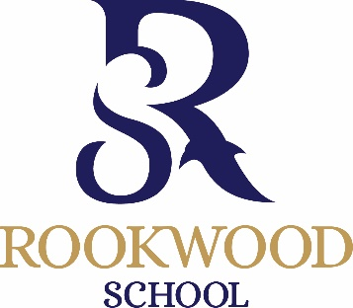
11+ Scholarship Application
September 2022
To be completed by parents of internal (current Rookwood pupils) and external applicants and returned to admissions@rookwoodschool.org or delivered to the school office by Monday 10th January 2022.

Child’s name ………………………………………………………………………... D.O.B. ……………………………………………
Address ........................................................................................................................................................................
……………………………………………………………………………………………………………………………………………………………….
……………………………………………………………………………………………………………………………………………………………….

Telephone No …………………………………………………………………… (Home)
…………………………………………………………………… (Mobile)
Present School: ……………………………………………………………………

I am interested in my son / daughter entering for the following scholarship(s), maximum of 2 practical subjects (marked *)
Please tick

Academic

Sports *

Art *
Please list instruments and grade:
Instrument | Grade

Drama *

Music *

Signed ……………………………………………………. Please print name ……………………………………………………

